9 Shopping List Project
94 Project requirements-
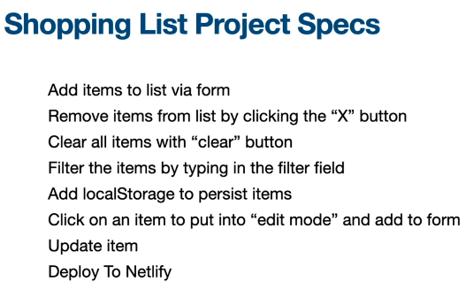
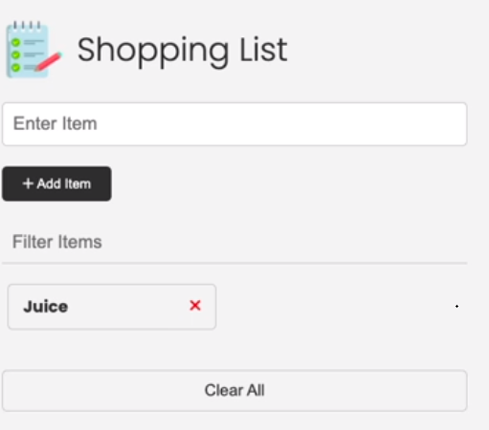
Filter will look for letter anywhere in the word.
Alter for delete prior to deleting
95 Add items to list – Brad broke this into several functions which seems overly complicated
96- Setting up Git and Git Hub
97 – remove and clear items-
Clearing an individual item , event delegation on the ul and travers dom to li.
While loop to clear all
98 don’t show clear and filter buttons if there are no list items
When page loads look for list items and if there are none do not show clear and filter.
Function that checks ui (or state of application)
Define the function that looks for lis inside the function that checks ui state, if defined in global scope the check for li ===0 will continue to be true.
99 filter –
Element: input event - The input event is fired every time the value of the element changes. This is unlike the change event, which only fires when the value is committed, such as by pressing the enter key or selecting a value from a list of options. Note that the input event is not fired when JavaScript changes an element's value programmatically.
Syntax
Use the event name in methods like addEventListener(), or set an event handler property.
addEventListener("input", (event) => {});
oninput = (event) => {};
using on input and .includes() method ok simple filter but seems inconsistent, asking TA
Here is TA’s response –

Will — Teaching Assistant

Hi Ar.
I would say that is the expected way to filter, and is much the same logic that is carried out in many sites that offer such functionality as usually you are searching for the occurrence of a word, so the characters appear together as you type.
You certainly can do as you wish though by doing something like:

- function filterItems(e) {
- const items = itemList.querySelectorAll("li");
- const text = e.target.value.toLowerCase();

- items.forEach((item) => {
- const itemName = item.firstChild.textContent.toLowerCase();
- for (const letter of text) {
- if (itemName.includes(letter)) {
- item.style.display = "flex";
- } else {
- item.style.display = "none";
- }
- }
- });
- }

Hope that answers it for you.

A
Add reply

100 local storage
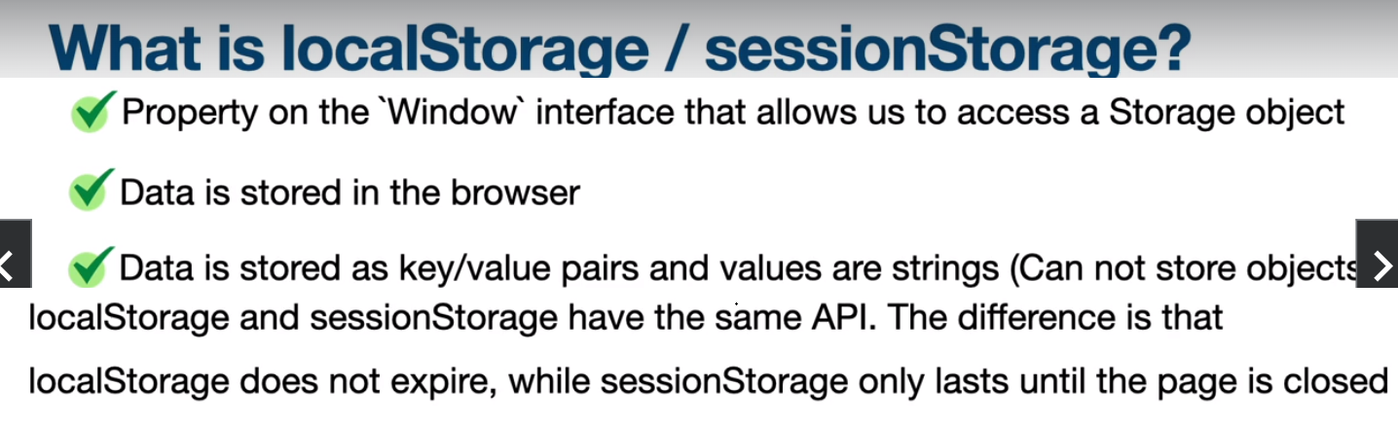
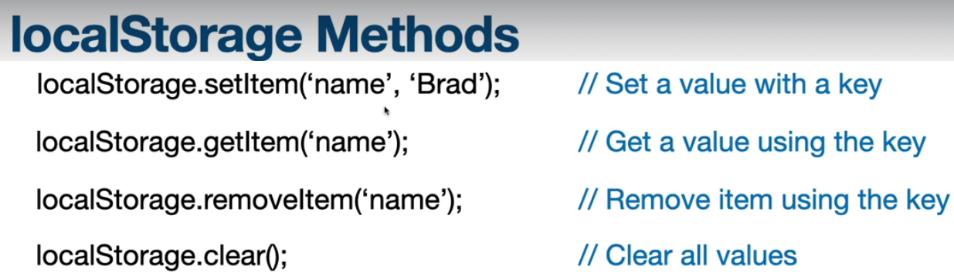
See what is in local storage by going to the application tab in dev tools
Objects must be stringified and do not use local storage for sensitive information
101 Add item to local storage
Add, remove fetch from local storage –
102- Fetch from local storage to display-
103 remove items in local storage
104 set item to edit
Click on the item then ,Change state of app to edit mode – use new function to set all to edit mode, target the item to edit, put its text in the input box and give user visual cues that app is in edit mode.
105 Update and Reset State –
106 – prevent duplicates
107 deploy to Netlify – https://www.udemy.com/course/modern-javascript-from-the-beginning/learn/lecture/37192582#questions
Simple front end free for small app
Upload to git hub, then select and deploy
Log in
Add new site , import from git hub then find project on github , then pick main and deploy ( could be another though ) then click deploy – could add custom domain form a place like name cheap or go daddy

Restart here :

